Relational Databases with MySQL Week 4 Coding Assignment

**Points possible:** 70

|  |  |  |
| --- | --- | --- |
| Category | Criteria | % of Grade |
| Functionality | Does the code work? | 25 |
| Organization | Is the code clean and organized? Proper use of white space, syntax, and consistency are utilized. Names and comments are concise and clear. | 25 |
| Creativity | Student solved the problems presented in the assignment using creativity and out of the box thinking. | 25 |
| Completeness | All requirements of the assignment are complete. | 25 |

**Instructions:** Using a text editor of your choice, write the queries that accomplishes the objectives listed below. Take screenshots of the queries and results and paste them in this document where instructed below. Create a new repository on GitHub for this week’s assignments and push this document, with your Java project code, to the repository. Lastly, in the Learning Management System, click the “Add Submission” button and paste the URL to your GitHub repository.

**Coding Steps:**

Write 5 stored procedures for the employees database.

Write a description of what each stored procedure does and how to use it.

Procedures should use constructs you learned about from your research assignment and be more than just queries.

**Screenshots:**

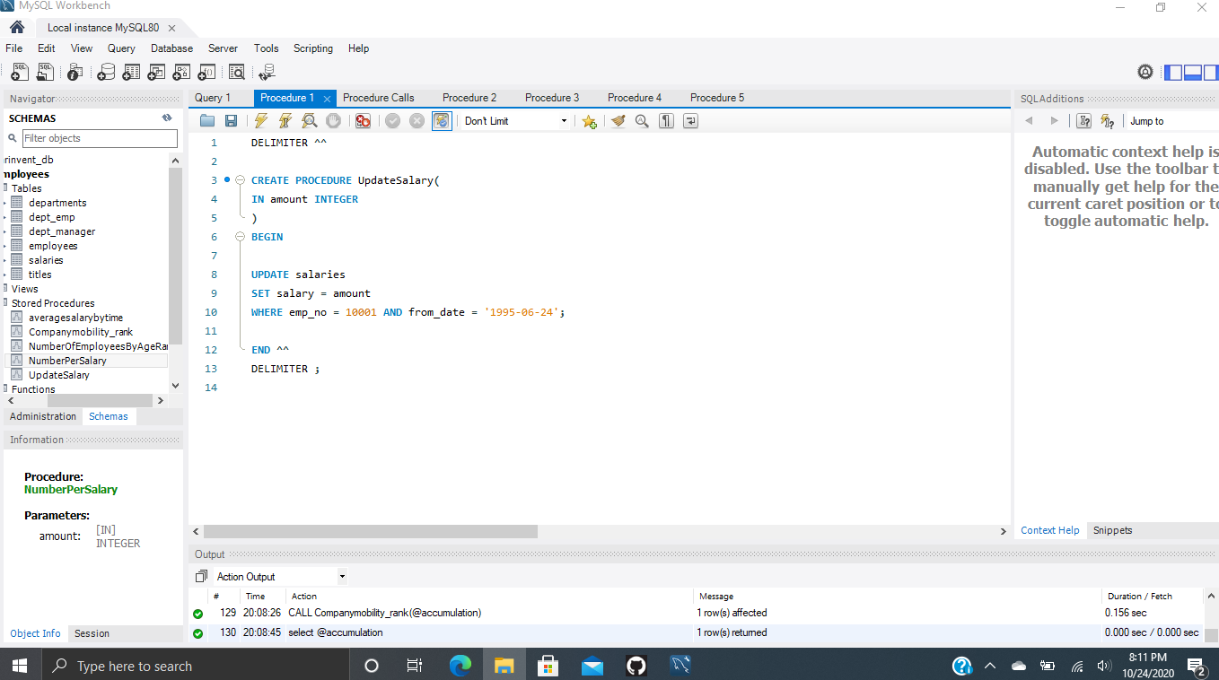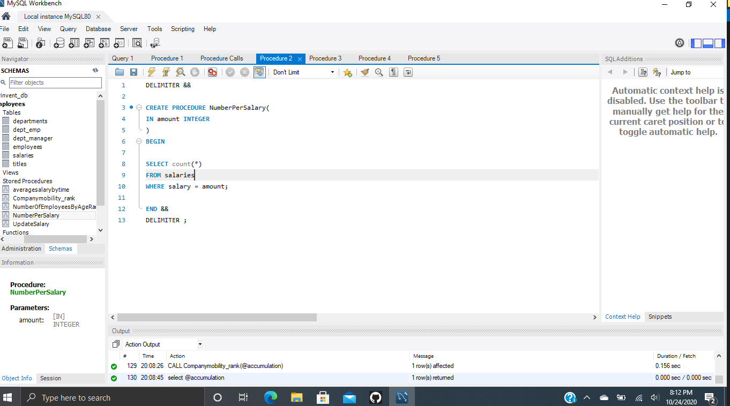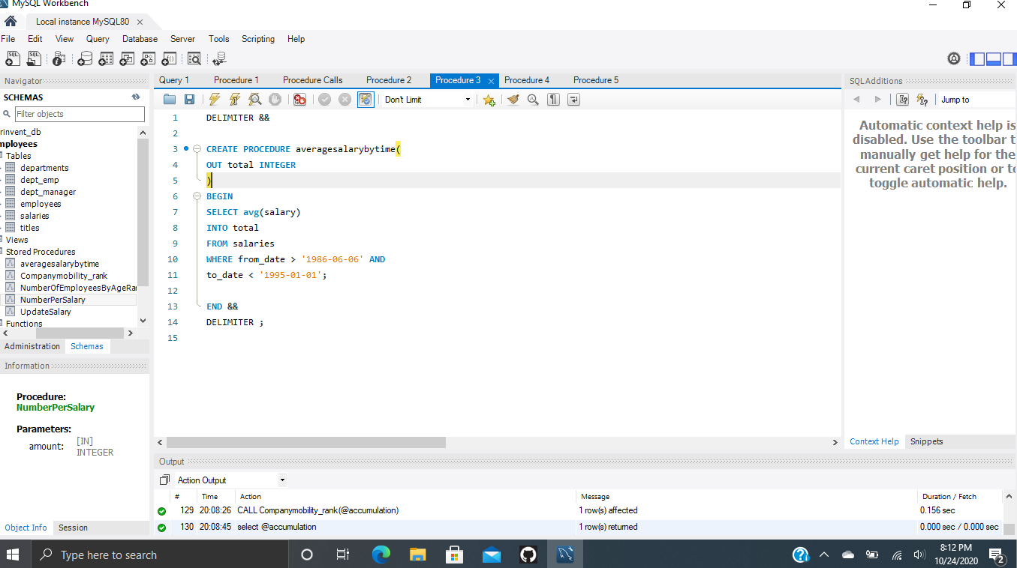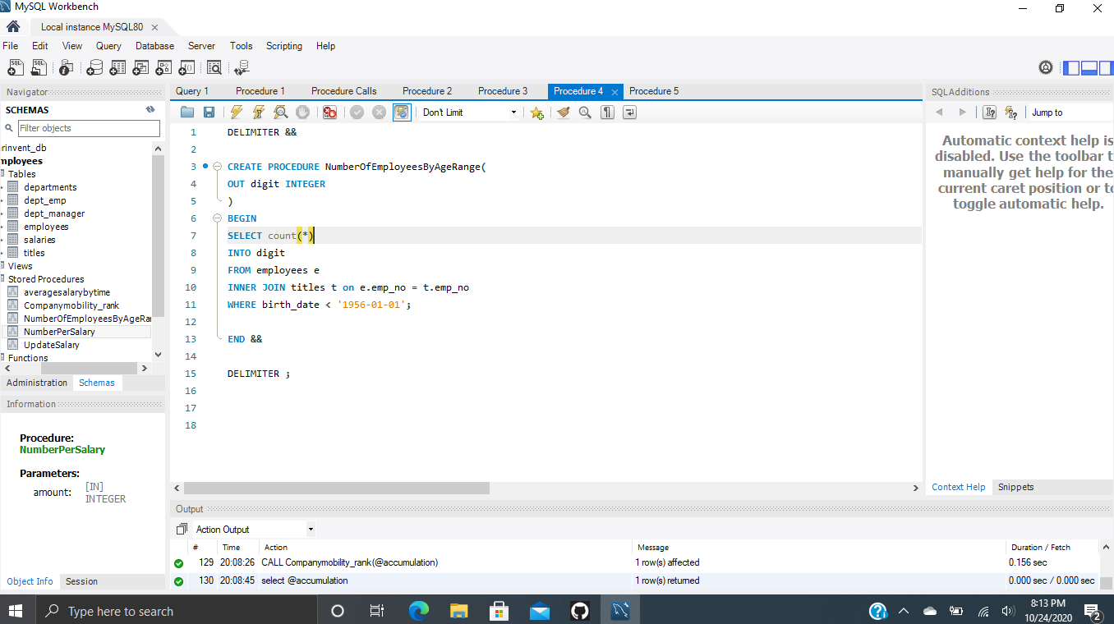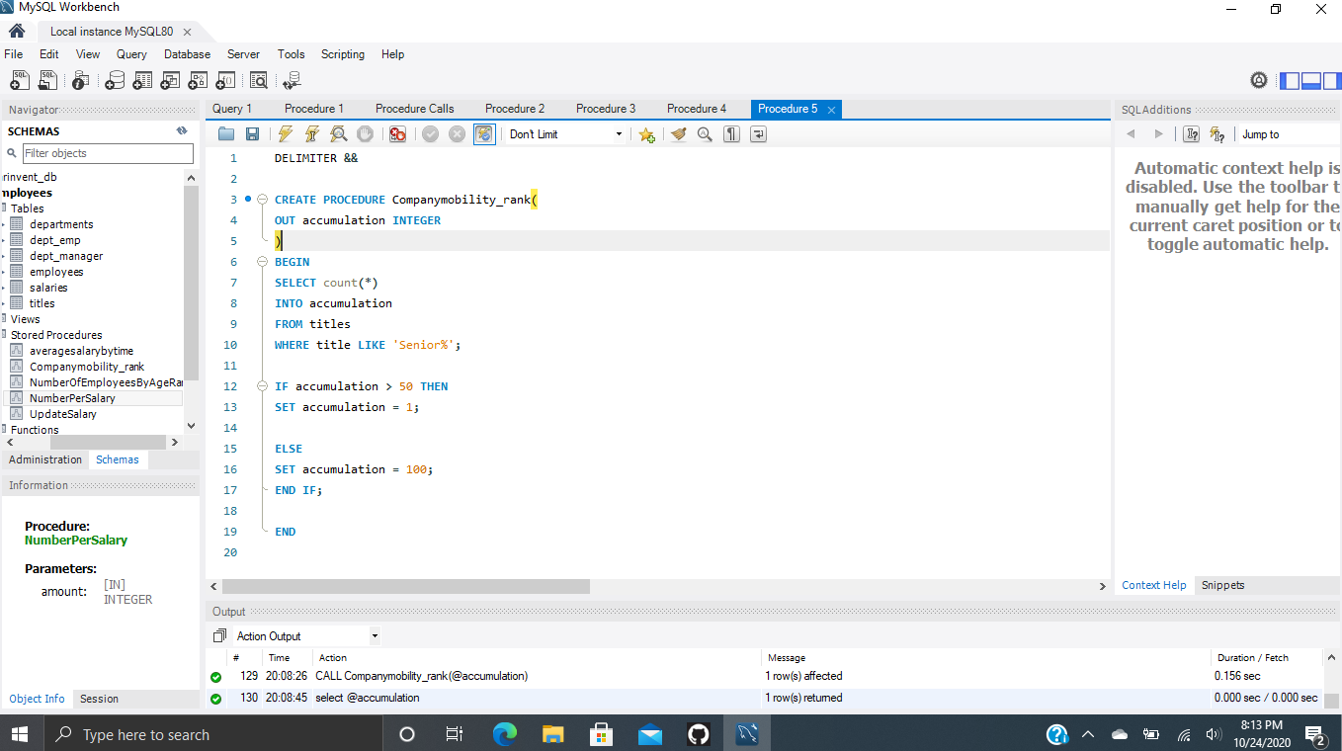

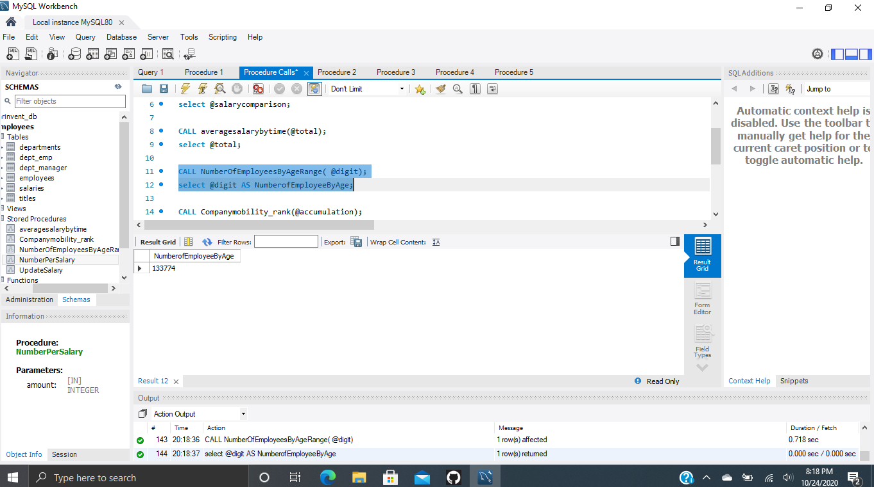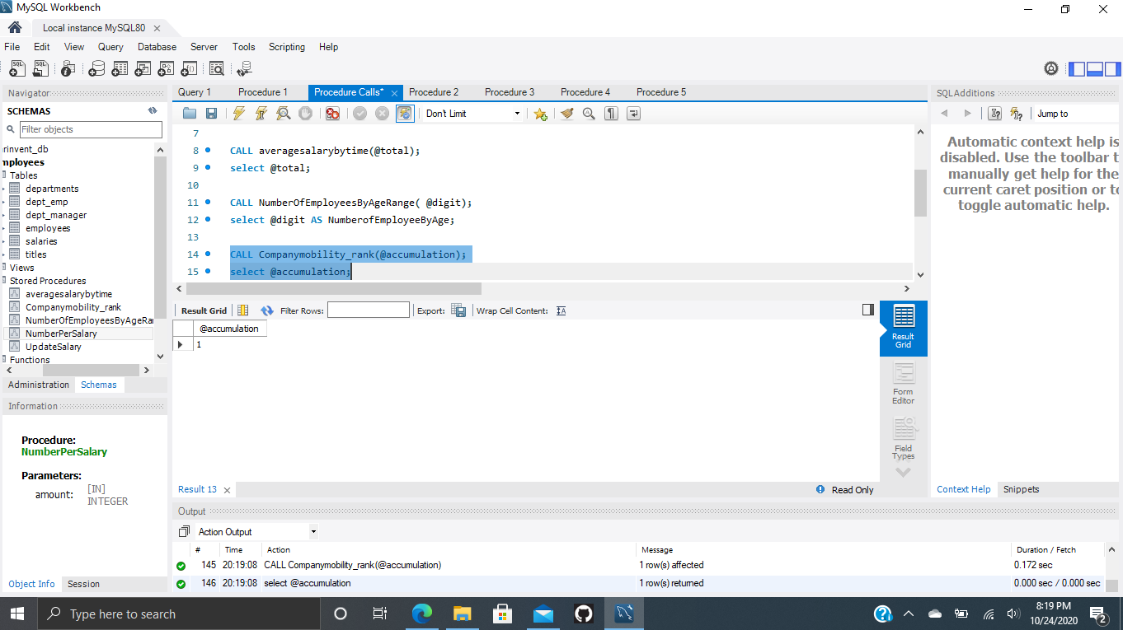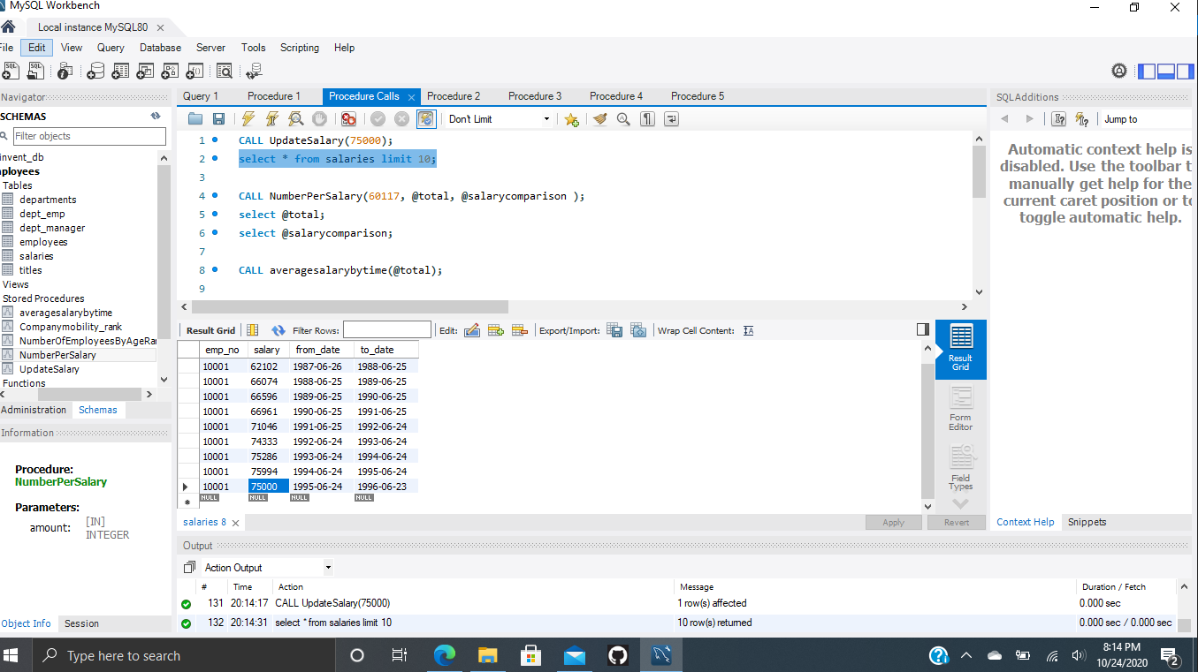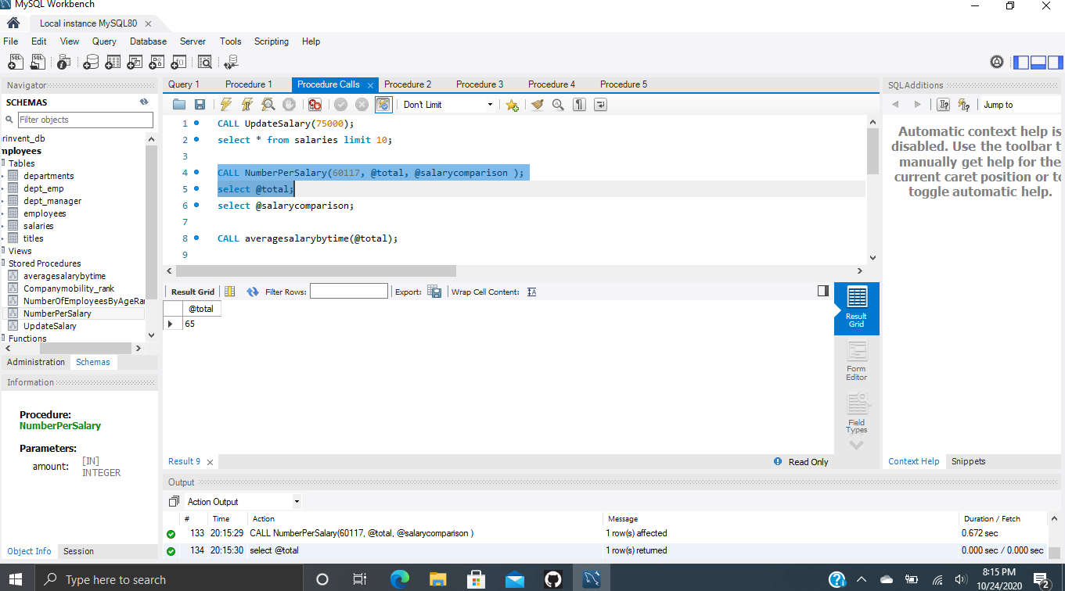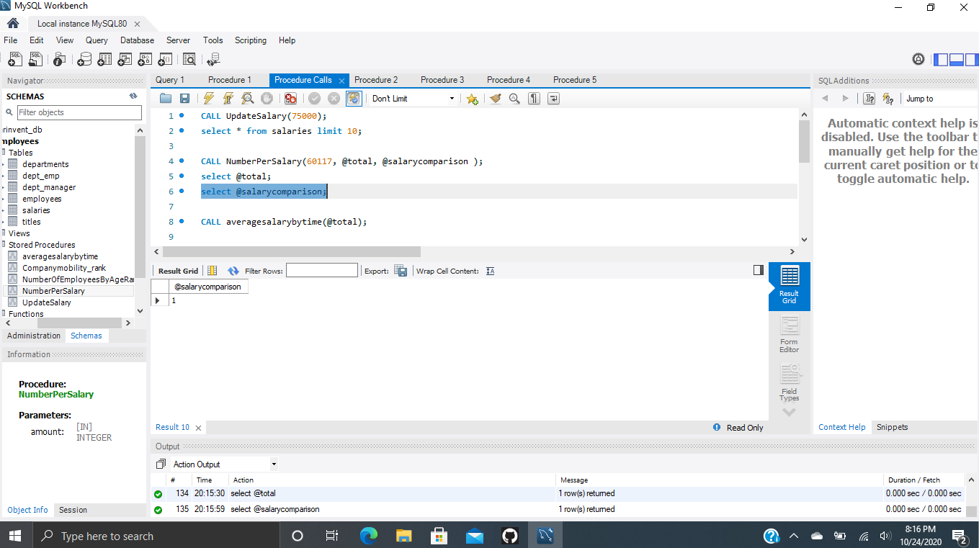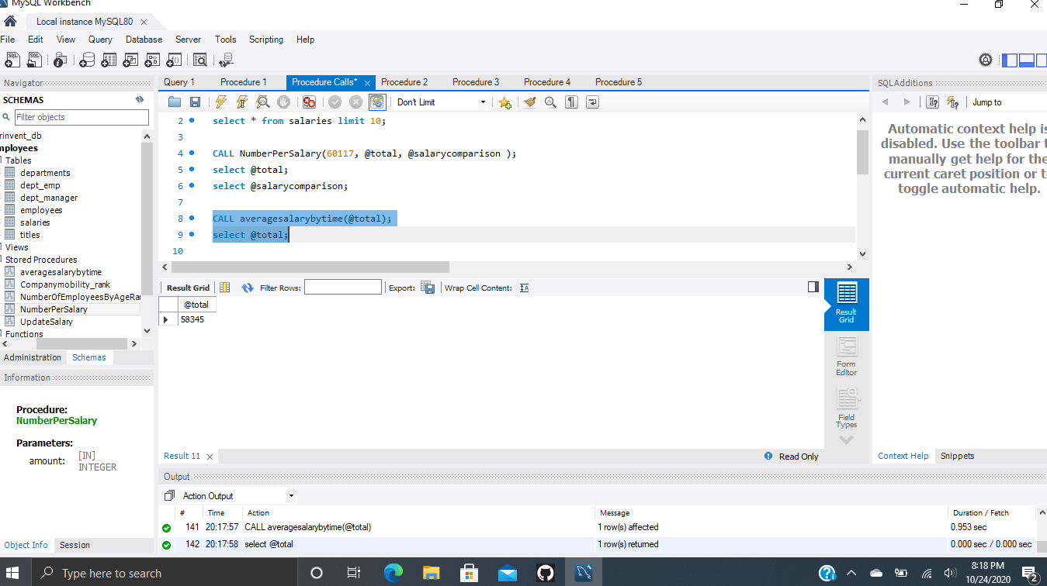

1. **Stored Procedure 1 uses an IN parameter. This procedure updates the salary amount for a certain employee starting at a certain date. The procedure takes in an integer in the parenthesis and updates that employees’ salary.**
2. **Stored Procedure 2 uses an IN parameter. This procedure gives a count for the number of salaries at a certain amount. The procedure takes in an integer and returns that number of salaries equal to that integer.**
3. **Stored Procedure 3 uses an OUT parameter. This procedure gives the average salary of employees based on the from and to dates. The out parameter is stored as a variable. A variable can be passed into the called stored procedure.**
4. **Stored Procedure 4 uses an OUT parameter. This procedure gives a count of the number of employees that are older than a certain date. The out parameter is stored as a variable. The variable can be passed into the called store procedure.**
5. **Stored Procedure 5 uses an OUT parameter. This procedure gives a count of the number of senior titles and ranks the company based off of how many titles are senior positions. If the amount of senior titles is greater than 50, the ranking will be equal to 1. If the amount of senior titles is less than 50 the ranking will be equal to 100. The variable can be passed into the called stored procedure.**

**URL to GitHub Repository:**

[**https://github.com/tjsun15/Mysql-week-4.git**](https://github.com/tjsun15/Mysql-week-4.git)